Blindband — Terminal 3 ADK submission
Confidential pay benchmarking in a TEE, with the result anchored on Solana.
Repository | https://github.com/bryankwandou/blindband
Live site | https://blindband.vercel.app (English · Bahasa Indonesia · 中文)
Mirror | https://bryankwandou.github.io/blindband — same commit, static export
Demo video | https://blindband.vercel.app/demo/blindband-demo.mp4 — 63 s, silent, captions on screen
Tenant DID | did:t3n:efd91540b28ceaccc876f9d1603d3f7f0d91d64d
Contract | z:efd91540…d91d64d:blindband v0.2.0, id 871
Round | 2026-q1, run 4 September 2026 on the sandbox
Digest | e4f528ad321626b2daf9b667188937609cd160a21a739d542eabd44a2f40beef
Solana anchor | 5uczxVJU…AJE3Hf, devnet, slot 492821211
Continue or hand over | I would like to keep running it — see the last section

1. The problem this agent is for
A group of firms wants to know what the market pays for a role. None will hand its payroll to a competitor, and none may lawfully swap *current* pay figures directly. The standard answer is a survey vendor: everyone mails a spreadsheet, the vendor promises confidentiality, and a PDF comes back months later. The members cannot see what happened in between, and neither can their regulators.
The rule that actually matters — that a benchmark must not become a channel for competitors to read each other's current pay — is enforced by nothing but an assurance. Competition authorities are specific about when such an exchange is defensible: a neutral aggregator, historical data, enough independent contributors, and no single contributor dominating the statistic.
Blindband turns those four conditions into code that runs where nobody can watch it, and then publishes evidence that it did.
This is a real enterprise workflow with a real compliance constraint, which is why it was chosen over the obvious demo shapes. It is deliberately not another policy gateway or generic "private data" wrapper.

2. What the enclave actually did
Round 2026-q1: 117 rows from 9 firms, submitted in a single execution.
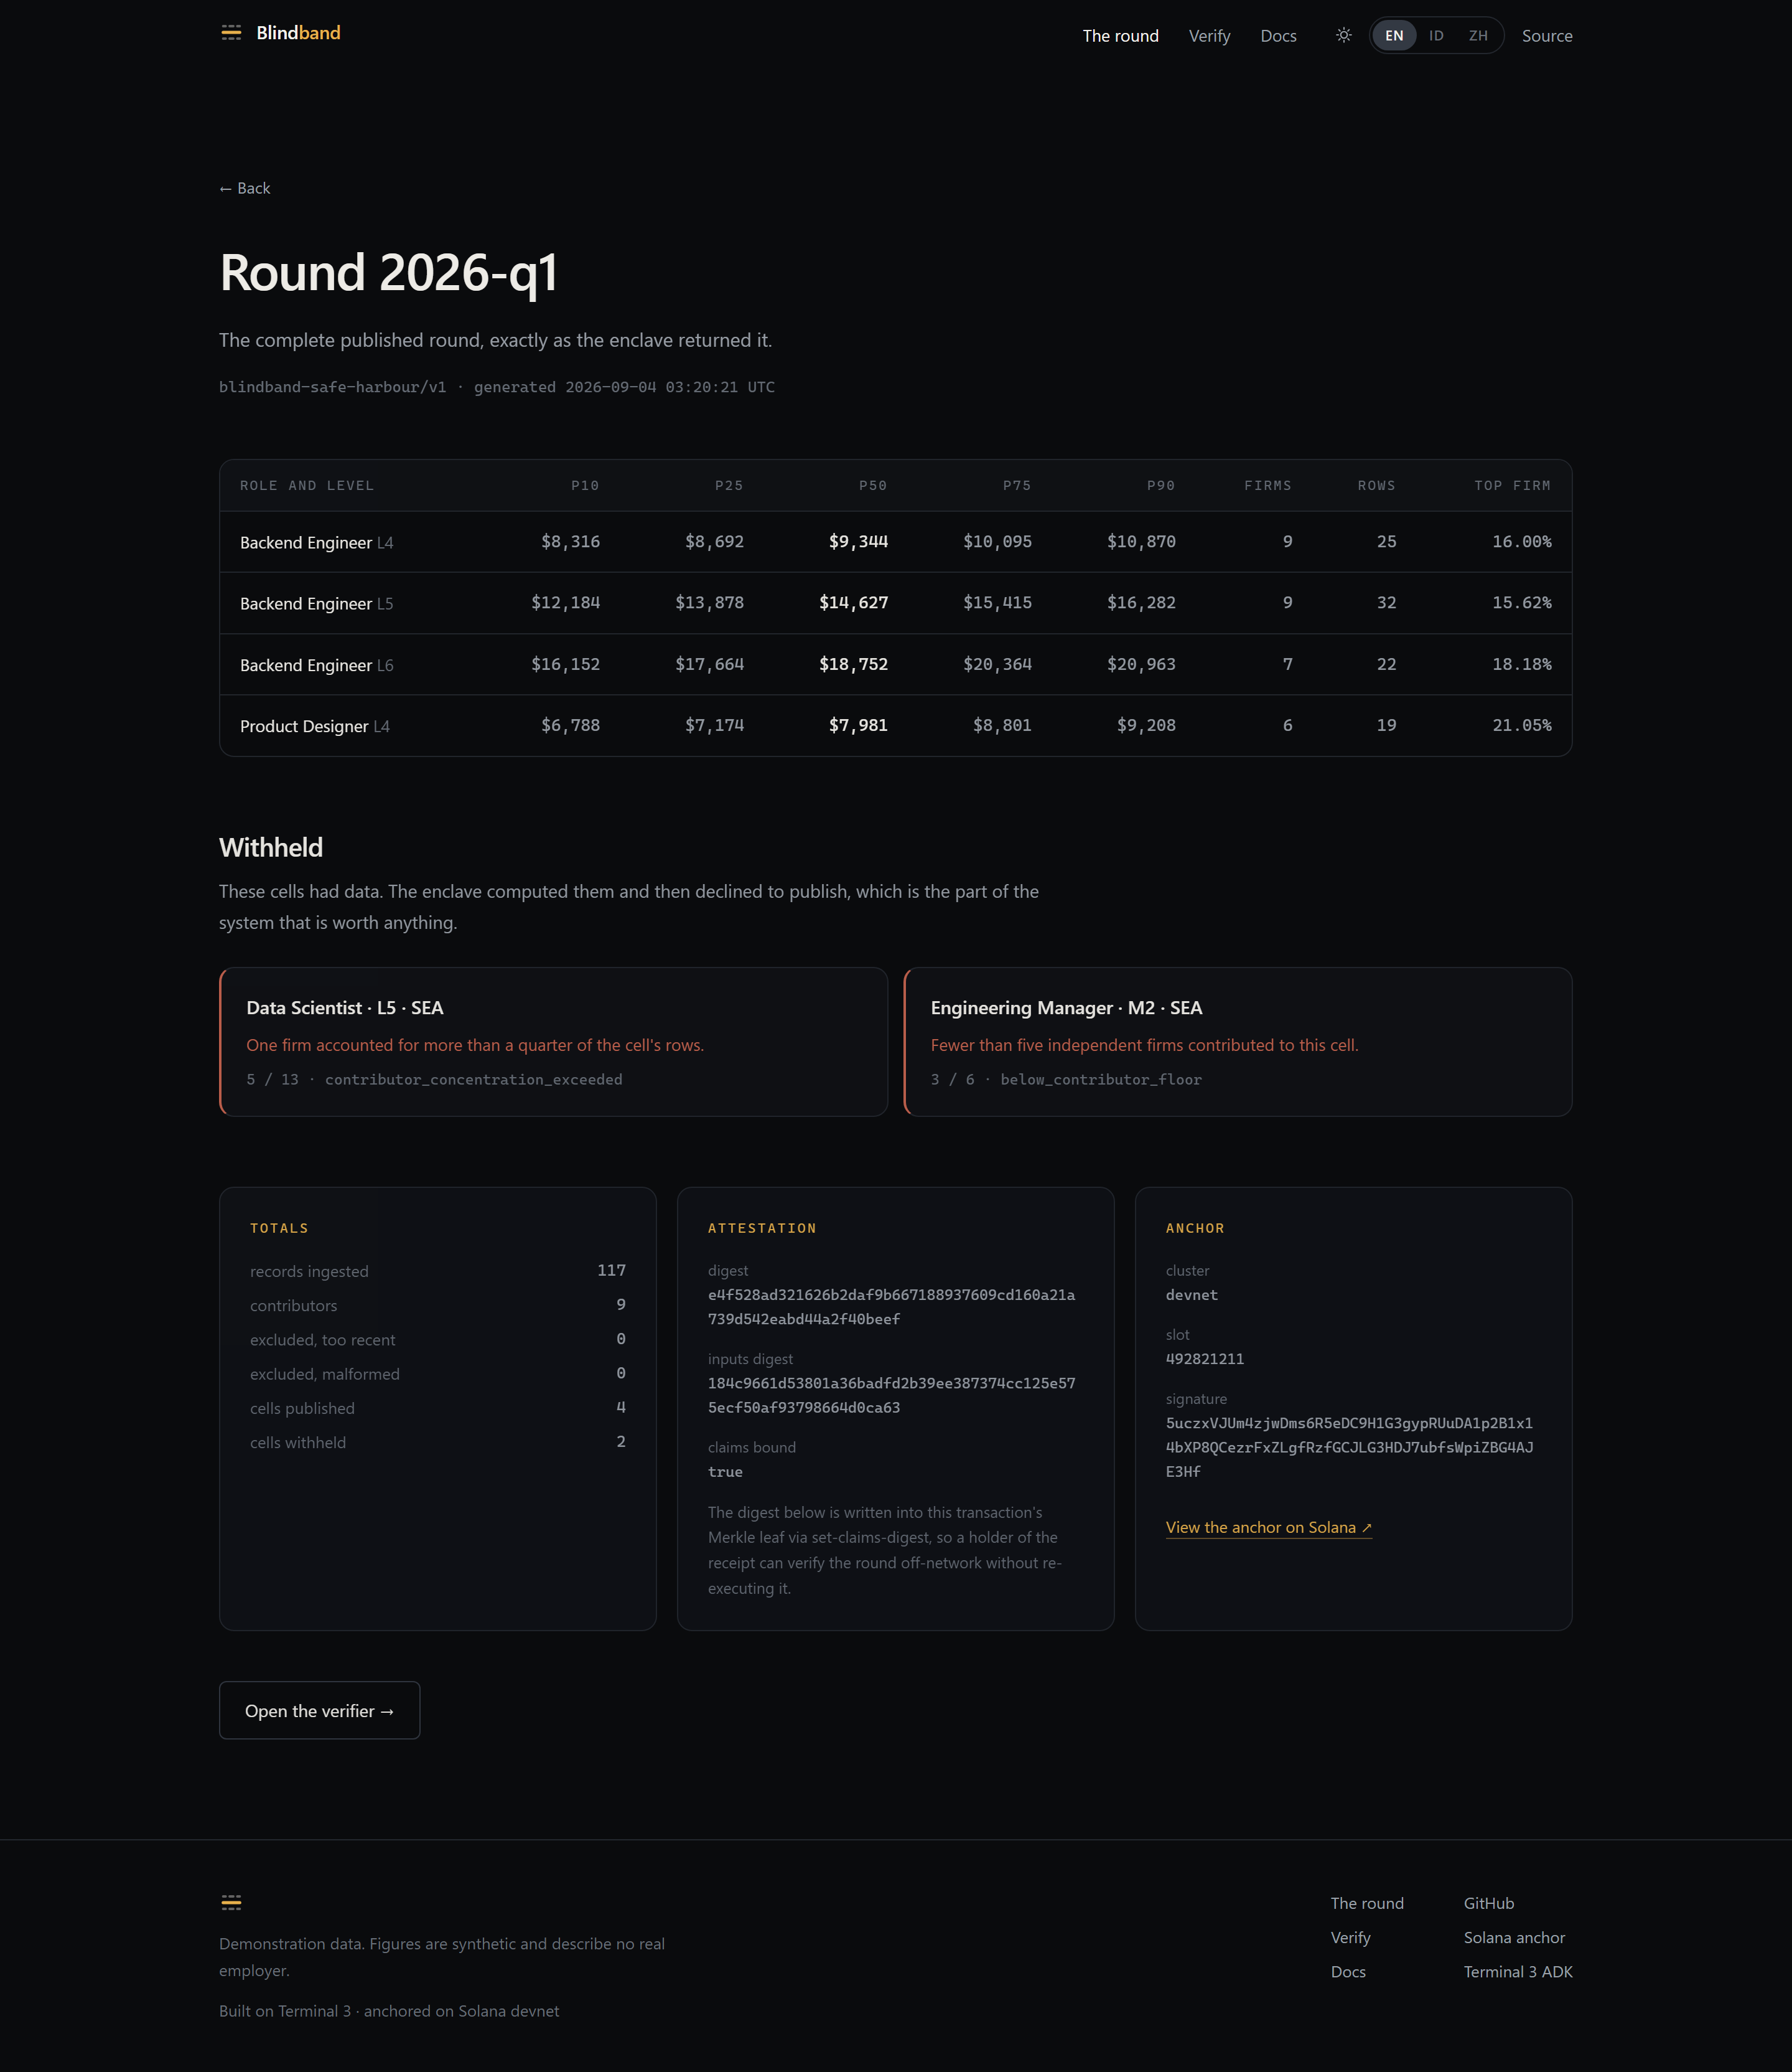
The published round
Published — 4 cells
Cell | P10 | Median | P90 | Firms | Rows | Top firm
Backend engineer L4 | $8,316 | $9,344 | $10,870 | 9 | 25 | 16.00%
Backend engineer L5 | $12,184 | $14,627 | $16,282 | 9 | 32 | 15.62%
Backend engineer L6 | $16,152 | $18,752 | $20,963 | 7 | 22 | 18.18%
Product designer L4 | $6,788 | $7,981 | $9,208 | 6 | 19 | 21.05%

Withheld — 2 cells, on two different gates
Cell | Reason | Firms / rows
Data scientist L5 | contributor_concentration_exceeded | 5 / 13
Engineering manager M2 | below_contributor_floor | 3 / 6

The withheld cells are the point. Both had enough data to compute; the enclave computed them and then declined to emit the numbers. One failed the concentration ceiling, the other the contributor floor — so the demonstration shows two independent gates firing rather than one rule repeated.

3. The four gates
Compiled into the contract as constants, named in every published round.
Gate | Rule | Where
Neutral aggregator | No member sees another's rows | ledger.rs — the map ACL names the contract identity alone; no function returns a row
Historical data | Effective date ≥ 91 days old | MIN_DATA_AGE_SECS
Contributor floor | ≥ 5 firms and ≥ 10 rows per cell | MIN_CONTRIBUTORS_PER_CELL, MIN_RECORDS_PER_CELL
Concentration ceiling | No firm above 25% of a cell | MAX_CONTRIBUTOR_SHARE_BPS

Blindband is engineering, not legal advice. The gates follow published safe-harbour guidance; fit to a specific consortium is a question for counsel.

4. Verification — three tiers of trust
Anyone can check the round, and two of the three checks need nothing from us.
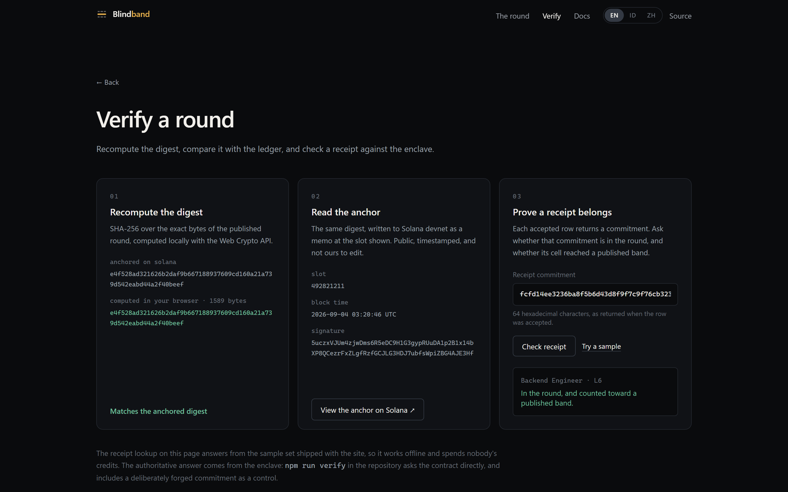
The verifier, with the digest recomputed in the browser
- Offline. SHA-256 over the exact bytes of the published round. The site does this in the visitor's own browser with the Web Crypto API; the CLI does it in agent/src/lib/digest.ts. Both hash the round value sliced verbatim out of the response — a value that has been through JSON.parse and back is not the same bytes and would not match.
- On chain. The same digest, written to Solana devnet as an SPL Memo. This gives the round an independent timestamp and an append-only history, so republishing a different round under the same id becomes obvious rather than impossible.
- Enclave. verify-receipt asks the contract whether a commitment is in the ledger and whether its cell reached a published band. npm run verify runs three probes: one receipt in a published band, one in a withheld cell, and one forged commitment as a negative control — because a verifier that only ever says yes has not been shown to distinguish anything.
All eight checks passed:
1. offline — digest over the bytes on disk
[ ok ] digest e4f528ad321626b2… over 1589 bytes matches the attestation
2. chain — the anchor on Solana devnet
slot 492821211, block time 2026-09-04T03:20:44.000Z
[ ok ] on-chain digest matches the round on disk
[ ok ] anchor names round 2026-q1
[ ok ] anchor names ruleset blindband-safe-harbour/v1
[ ok ] anchor carries 4 published / 2 withheld
3. enclave — receipt inclusion, asked of the contract
[ ok ] receipt in a published band → included true, counted true
[ ok ] receipt in a withheld cell → included true, counted false
[ ok ] forged commitment → included false
verdict : every check passed.

5. The walkthrough
The site replays the five real commands rather than embedding a screen recording — the transcript can be paused on the line you care about, the text can be selected, and it does not go stale when an output string changes.
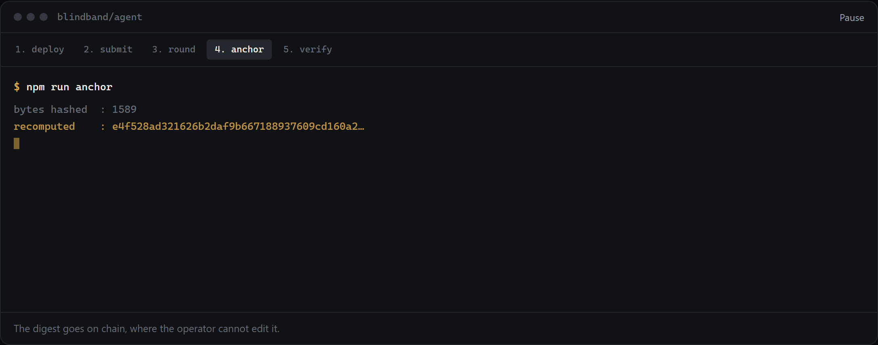
The walkthrough player
npm run deploy # register + scope the sealed maps
npm run submit -- data/records.json # 117 rows, one execution
npm run round -- 2026-q1 # aggregate inside the enclave
npm run anchor # write the digest to Solana devnet
npm run verify # check all of the above
Each step refuses to proceed if the previous left something inconsistent. anchor recomputes the digest locally and will not write to the chain if it does not match — anchoring an unverified digest would put a number on a public ledger and call it proof.
There is also a 63-second video, in video/ as Remotion compositions and served at /demo/blindband-demo.mp4. It is silent and captioned on screen, and every figure in it — the firm count, the bands, the withheld reasons, the digest, the slot — is read from the same two data files the site reads. npm run render in video/ rebuilds it, so a number in the video cannot drift from the round it claims to show.

6. Ease of maintenance
This was the judging criterion the design was actually organised around.
- The interesting logic runs without the platform. stats.rs and
policy.rs are pure and unit-tested; cargo test runs 23 tests on the host toolchain in under a second, with no node, no enclave and no credits. Only ledger.rs touches the host, and it is wasm32 only.
- Deploy is idempotent and self-healing. npm run deploy tracks every
contract id the tenant has registered and re-scopes both map ACLs to the union, so a version bump cannot orphan rows written by the previous build. This was a bug before it was a feature — see BB-03.
- One state file. agent/state.json holds the tenant DID, the contract
ids and the map names. Nothing else lives outside git, and a single deploy reconstructs it.
- Minimal capability surface. ["kv_store", "logging", "tenant_context"].
No http, so there is no egress to review or allowlist.
- The reasoning is in the files. Each module's header explains why it works
the way it does — particularly the two places where the obvious approach is wrong (session vs. flat invoke, and writing the round verbatim).
- The site is static. Three locales, fifteen prerendered pages, no runtime
backend, no API route that could be drained of test credits by a crawler.
- It is not tied to one host. The default build is the Vercel one; setting
BB_STATIC_EXPORT=1 produces a folder of files instead, which is what the GitHub Pages mirror serves from the same commit. Whoever inherits this is not inheriting a hosting account along with it.

7. The site
English is the default; Bahasa Indonesia and 中文 are hand-written, not machine -passed — "withheld" and "hidden" mean materially different things here.
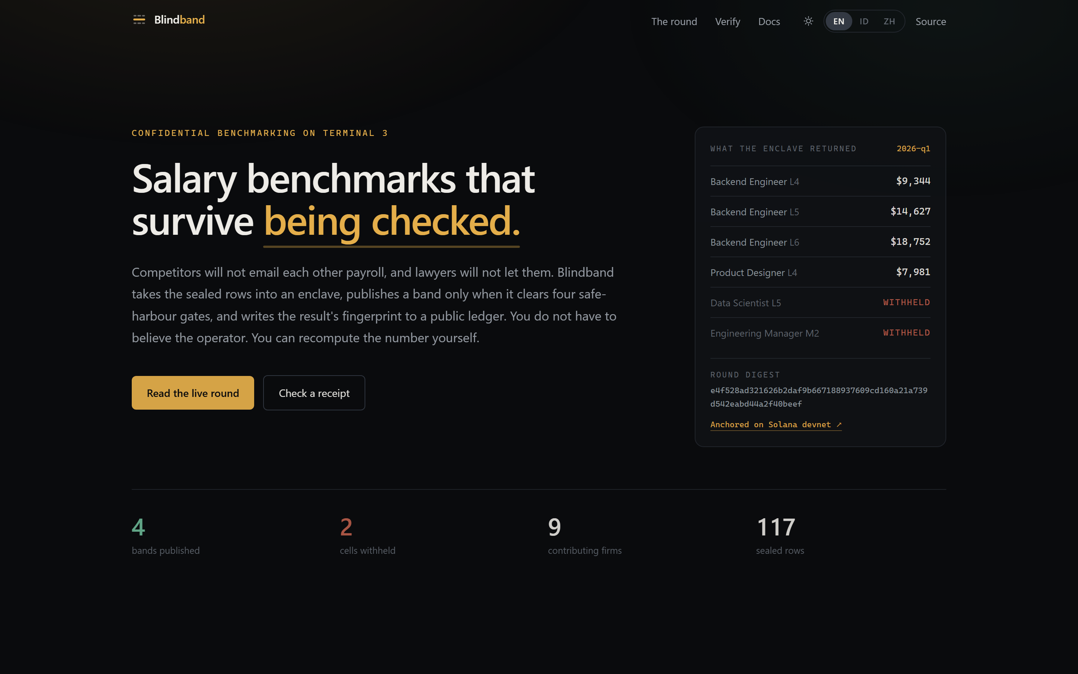 | 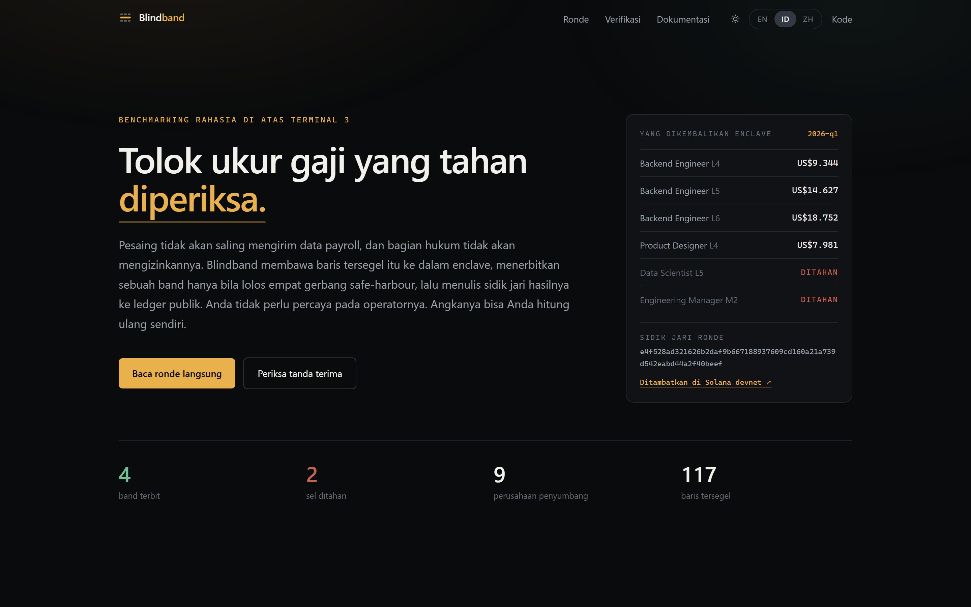
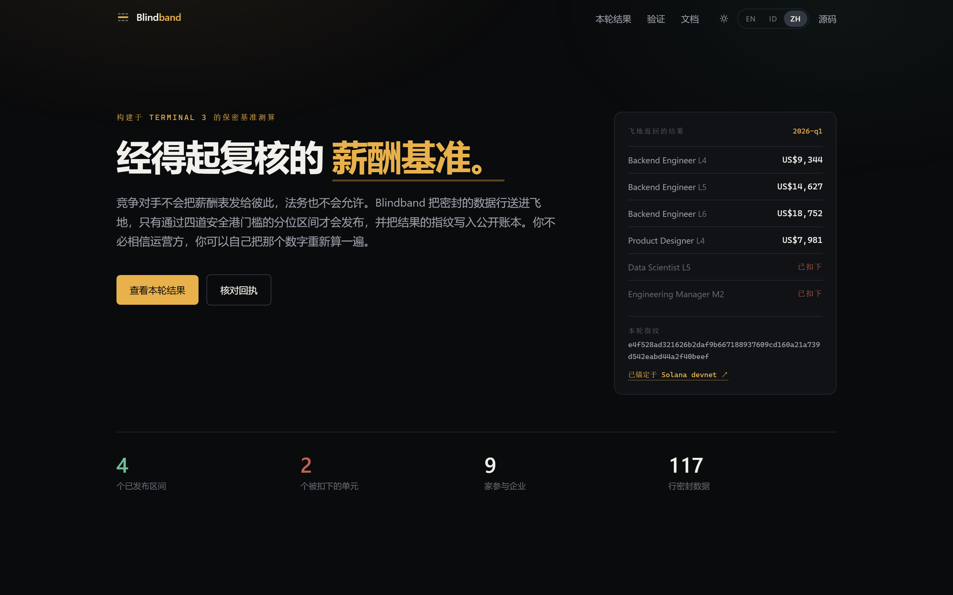 | 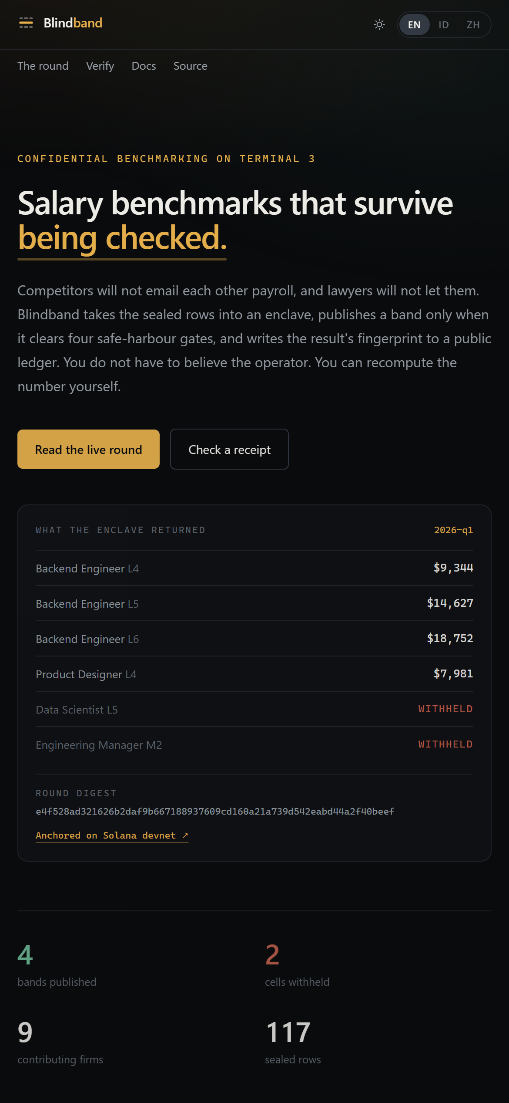
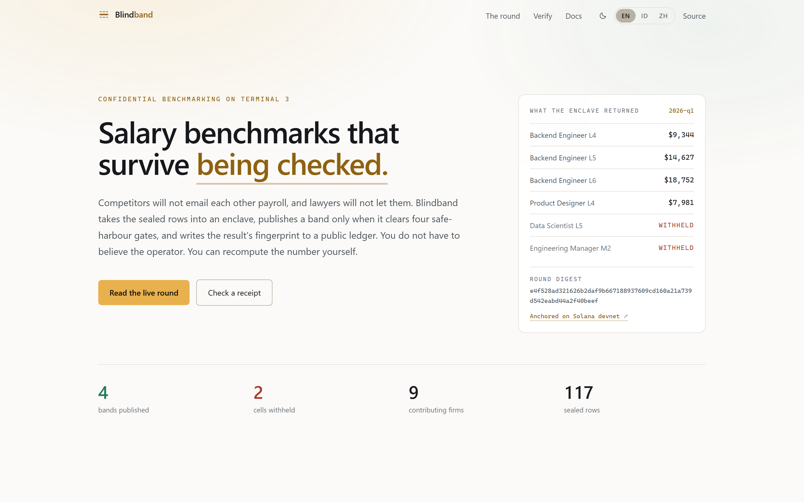 | 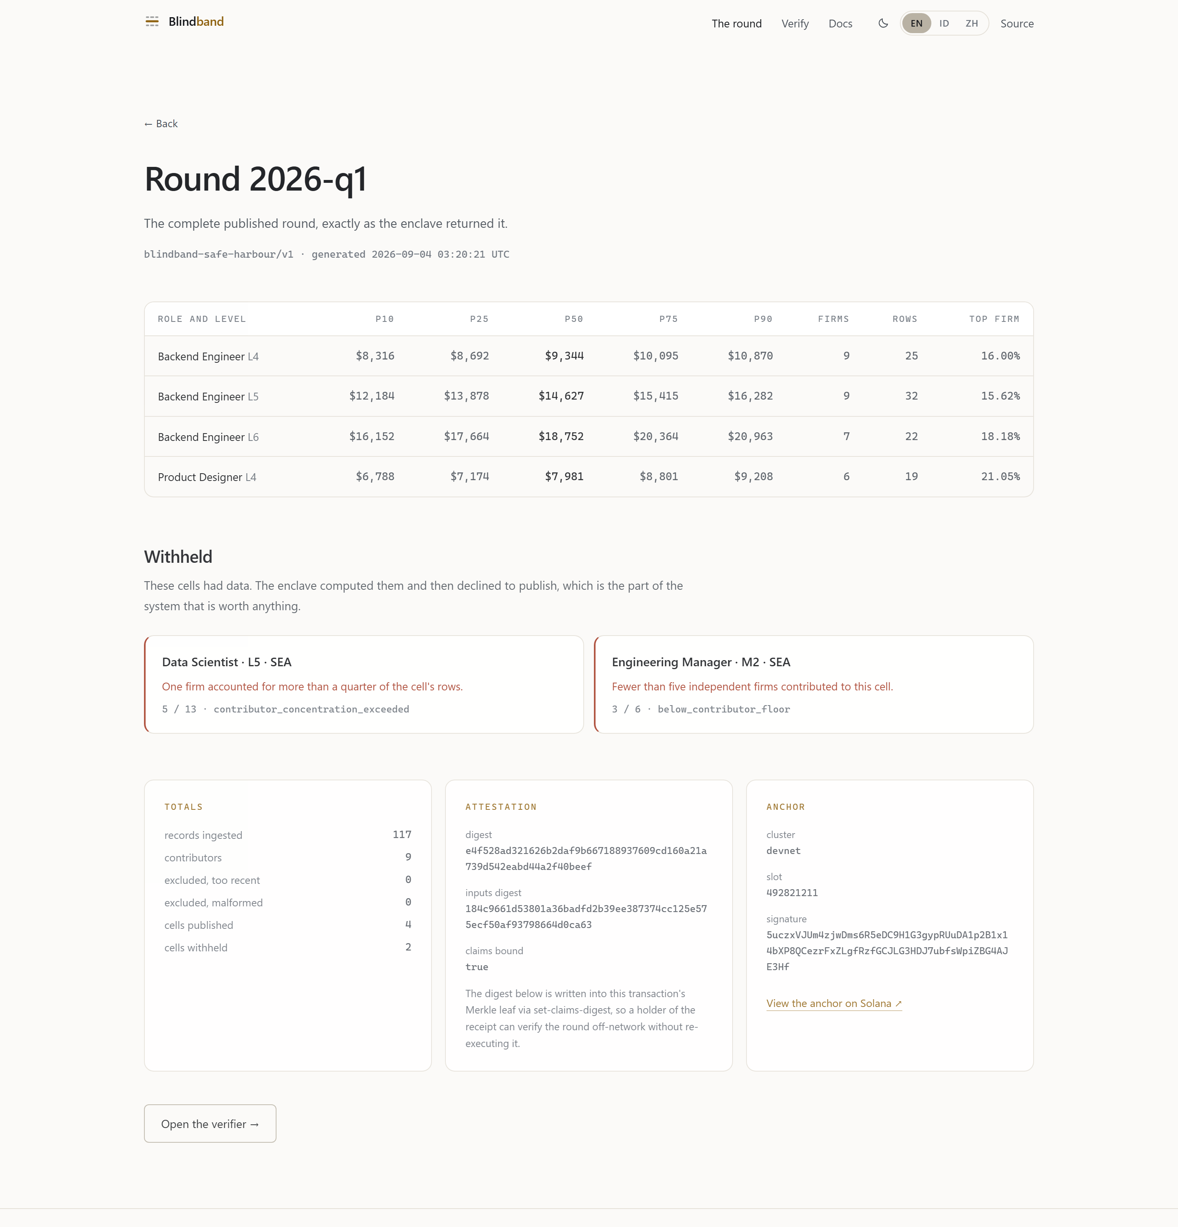

Every figure on the site is read from the round file at build time. The chart plots all cells on one axis and keeps the withheld ones in place — dropping them would hide the most interesting thing the enclave did.
The landing page opens on the round rather than on a claim about it: beside the headline sits the enclave's own output — four medians, the two cells it refused to publish, the digest, and the link to the anchor — so the first thing a reader sees above the fold is the thing they are invited to check.
There are two themes. The site follows the reader's operating system on a first visit and remembers an explicit choice after that, applied by an inline script before first paint so nobody watches a dark page turn light. Every colour is a role rather than a value — ink is the page ground in both themes — which is why the swap is one stylesheet and not a second set of components. The light palette was re-derived rather than inverted: the dark amber is 2.1:1 on white and would have failed, so text amber, green and rust all have their own light values, and every pair clears WCAG AA (ivory 17.0:1, quiet 7.5:1, faint 4.7:1, signal 5.1:1, published 5.1:1, withheld 6.2:1).

8. Bugs
Twelve write-ups with symptom, cause, fix and cost are on the docs page and in web/src/lib/bugs.ts. Six are platform issues, six are our own — kept in the report because pretending otherwise would make the other six less credible.
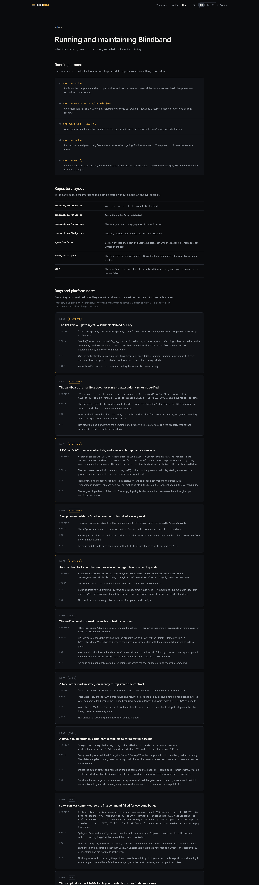
The bug write-ups

Platform
BB-01 — the flat `invoke()` path rejects a sandbox-claimed API key. invalid api key: malformed api key token, for every request regardless of body or headers. invoke() expects an opaque t3n_key_… from organisation agent provisioning; a key claimed from the community sandbox page is a hex secp256k1 key for the SIWE session flow. The error names neither. *Fix:* use tenant.contracts.execute(). *Cost:* about half a day, most of it spent assuming the request body was wrong. Suggested doc change: the quickstart should say which key type each dispatch path takes.
BB-02 — the sandbox trust manifest does not parse, so attestation cannot be verified. Trust manifest at https://cn-api.sg.testnet.t3n.terminal3.io/api/trust-manifest is malformed. The SDK then requires T3N_ALLOW_UNVERIFIED_NODE=true. The SDK's behaviour is correct — it declines to trust a node it cannot attest. But the one property a TEE platform sells is currently the property that cannot be checked on its own sandbox. Every run in this repository prints the warning rather than hiding it.
BB-03 — a KV map's ACL names contract *ids*, and a version bump mints a new one. After registering v0.2.0: kv_store.get on 'z:…:bb-rounds' read denied: access denied: TenantContract(did:t3n:…/871) cannot read map — with an empty log ring, because the contract dies during instantiation before it can log. *Fix:* track every id and re-scope with tenant.maps.update(). *Cost:* the longest single block of the build; the empty log is what made it expensive. Suggested doc change: the KV maps guide should mention both the id coupling and maps.update().
BB-04 — a map created without `readers` succeeds, then denies every read. The governor defaults to deny; an omitted readers set is a closed map, not an open one. The failure surfaces far from the call that caused it.
BB-05 — an execution locks 10,000,000,000 base units against a 20,000,000,000 allocation, though a round settles at ~150,000,000. The lock is a worst-case reservation, released on completion. It silently rules out the obvious per-row API design — 117 rows one call at a time would need 117 executions. Worth stating on the test-tokens page, because it shapes the contract interface, not just the budget.

Ours
BB-06 — the verifier could not read the anchor it had just written. Memo on 5uczxVJU… is not a Blindband anchor, reported against a transaction that was one. SPL Memo v2 echoes the payload into the log as a JSON *string literal*; slicing between the outer quotes leaves the escapes in. *Fix:* read the decoded instruction data from getParsedTransaction, with a properly unescaped log fallback. A false negative that looks exactly like tampering is the worst failure mode a verification tool has.
BB-07 — a byte-order mark in `state.json` silently re-registered the contract. readState() caught the parse failure and returned {}, so the deploy believed nothing was registered. The deeper fix is that an unparseable state file should stop the deploy rather than be treated as empty state.
BB-08 — a default build target made `cargo test` impossible. could not execute process … z_blindband-….wasm / %1 is not a valid Win32 application (os error 193). .cargo/config.toml set [build] target = "wasm32-wasip2" to shorten the component build; that default applies to cargo test too, so cargo compiled the test harnesses to wasm and then tried to run them natively. *Fix:* drop the default and name the target on the one command that needs it. Worth recording because the repository was claiming the gates were covered by a command that did not run — found by executing every command in our own documentation before publishing, which is the only reason it is not still true.
BB-09 — `state.json` was committed, so the first command failed for everyone but us. A clean clone carried our tenant DID and contract ids 870/871. Deploying with a different key printed contract : reusing z:efd91540…:blindband (id 871) — a namespace that key does not own — registered nothing, and scoped the new tenant's maps to readers: { only: [870, 871] }. The first submit would then die with AccessDenied and an empty log ring: the exact failure BB-03 exists to describe, re-inflicted on every reader by our own packaging. *Fix:* untrack the file, and have the deploy compare state.tenantDid against the DID it just connected as — foreign state is now announced and discarded rather than used. An unparseable state file is fatal too, which is the deeper fix BB-07 identified and did not make at the time.
BB-10 — the sample data our own quickstart tells you to submit was not in the repository. .gitignore held data/*.json with a !data/.gitkeep exception, and .gitkeep was never created, so git dropped the directory entirely. npm run submit -- data/records.json referred to a file no clone contained. *Fix:* ignore the four generated artefacts by name and track records.json; the 117 rows are synthetic, nine members named member-01…member-09.
Both were found the same way, and only that way: by cloning this repository from GitHub into an empty directory and reading it as someone who had never seen it. Everything had been tested on the machine that wrote it, where both files were sitting on disk. That is worth stating plainly under a judging criterion about maintenance — the repository claimed to be reproducible in three places while being reproducible by nobody.
BB-11 — a sandbox tenant cannot provision the delegated agent identity the SDK offers it. client.createAgent(did, "blindband-round-runner") is present and callable, and on a sandbox-claimed DID it returns RPC Error: organisation has no policy meta. *Cause:* createAgent expects an *organisation* DID whose caller is an admin of it; a DID claimed from the community sandbox page is not an organisation and carries no policy metadata. This is BB-01's tier boundary seen from the other side — the opaque t3n_key_… that the flat invoke() path demands is exactly what createAgent would have returned. *Fix:* none from this tier. Rounds run under the tenant identity, and the report says so rather than implying an agent key that does not exist. npm run probe:agent makes the call in one command and prints whatever the platform answers, so the next person can tell in seconds whether their tier has lifted. *Cost:* no lost time, but it is the largest remaining gap between what this is and what an agent on this platform is meant to be, and it is not closable by writing better code.

9. Trying it yourself
The reviewer should not have to take any of the above on trust, and does not have to ask us for anything to avoid it. One command, no key, no credits, no account:
git clone https://github.com/bryankwandou/blindband && cd blindband/agent
npm install
npm run judge
round : 2026-q1 (blindband-safe-harbour/v1)
submissions : 117 rows, read from agent/data/records.json
rpc : https://api.devnet.solana.com
[ ok ] the gates and the maths, recomputed from the raw submissions
70 fields agree — 4 cells published, 2 withheld (contributor_concentration_exceeded, below_contributor_floor)
[ ok ] the digest, recomputed from the published bytes
1589 bytes hashed → e4f528ad321626b2…2f40beef — the digest the enclave attested
[ ok ] the digest, read back off Solana devnet
tx 5uczxVJUm4zj… carries d=e4f528ad321626b2… for round 2026-q1,
written at slot 492821211 — before you asked, and not by anything of ours
[ ok ] the negative controls — a verifier that can say no
one median raised by $0.01 → 843d5cdd8ecf6a87…, rejected
one salary raised by $1.00 → recomputation diverges, rejected
──────────────────────────────────────────────────────────────────────
4/4 checks passed. The published round is the one the enclave
produced from these submissions, and the chain agrees.
The first check is the one that matters most and the one that took the most care to make honest. agent/src/lib/recompute.ts is a second implementation of the four gates and the percentile maths — written in TypeScript against policy.rs and stats.rs, sharing no code with them. It reads the 117 raw submissions, folds them into a round of its own, and diffs that against the published round field by field: every percentile, every mean, every contributor count, every top-contributor share, and both withholding reasons. Seventy fields have to agree. A table of plausible-looking numbers typed in by hand does not survive it, and neither would a subtle change to a gate threshold.
The fourth check exists for the opposite reason. A verifier that only ever prints ok is worthless, and from the outside it looks identical to one that works. So the harness tampers with its own inputs — one median raised by a cent, one salary raised by a dollar — and requires both to be rejected before it reports success.

Running the agent, not just checking its homework
Verifying a past round is one thing; a reviewer is entitled to ask whether the agent can be *used*. It can, on their own data, offline, with no account:
cd contract
cargo run --example replay -- examples/payroll-sample.csv --round-id demo
ingested 30 rows from 5 contributors — 5 too recent, 0 malformed
1 cells published, 2 withheld
PUBLISHED
cell cur p10 median p90 firms top firm
backend engineer l4 EUR 6916.00 7415.00 8009.00 5 25.00%
WITHHELD
data scientist l5 contributor_concentration_exceeded 5 firms / 10 rows
engineering manager m2 below_contributor_floor 3 firms / 3 rows
This is not a demonstration written to look like the enclave. It calls policy::aggregate and policy::round_digest out of the same crate that was compiled to wasm32-wasip2 and registered as the component — the same code paths, the same constants, the same gates. The enclave is what keeps the inputs sealed from the other members; it does not get a vote on the arithmetic.
The sample file makes all four gates fire in one run, deliberately. The one published cell sits at exactly 25.00% concentration — one row either way and it is withheld. The five product designer rows never reach the maths, because their pay is effective in 2030 and gate 1 drops anything less than 91 days old.
A reviewer can point it at their own extract instead. The header row is the whole schema:
contributor,role,level,region,currency,base_minor,effective_at
acme,Backend Engineer,L4,EU,EUR,720000,1755000000
Move a salary, remove a contributor, change a date, and watch cells stop being publishable. That is the product argument, made on the reviewer's own numbers rather than ours.

Deriving the anchored digest on your own machine
The same command rebuilds the round that is on Solana:
cargo run --example replay -- --replay
digest : e4f528ad321626b2daf9b667188937609cd160a21a739d542eabd44a2f40beef
expected : e4f528ad321626b2daf9b667188937609cd160a21a739d542eabd44a2f40beef
[ ok ] this machine derived the digest that is anchored on Solana devnet.
Same inputs, same code, same answer — no enclave, no key, no network.
agent/data/receipts.json is committed for this reason: the commitments it holds are what allow the 117 submissions to be reconstructed exactly as the ledger held them, rather than approximately. With them, a laptop with no credentials derives e4f528ad…beef — the digest written to devnet on 4 September, in a transaction that predates the reviewer's interest in it.
The four checks in npm run judge show the published round is internally consistent and that the chain agrees. This shows something stronger: the round is *derivable*. Nothing about it has to be taken on our word, including the claim that an enclave ran it.

Reading the anchor without any of our code
Only the third check needs the internet, and it reaches a public Solana RPC endpoint rather than anything we run. The same fact can be read with curl and no code of ours at all:
curl -s -X POST https://api.devnet.solana.com -H 'Content-Type: application/json' \
-d '{"jsonrpc":"2.0","id":1,"method":"getTransaction","params":["5uczxVJUm4zjwDms6R5eDC9H1G3gypRUuDA1p2B1x14bXP8QCezrFxZLgfRzfGCJLG3HDJ7ubfsWpiZBG4AJE3Hf",{"encoding":"jsonParsed","maxSupportedTransactionVersion":0}]}'
Or press the button on /en/verify, where the digest is recomputed in the browser with the Web Crypto API.
The gates also carry their own unit tests, with no node and no JavaScript:
cd contract && cargo test # 23 tests on the percentile maths and the four gates
Only the third tier — asking the enclave itself — needs a T3N key, because it spends the reviewer's credits rather than ours:
cd agent && cp .env.example .env # T3N_API_KEY, SOLANA_SEED_HEX
npm run deploy -- --dry-run # free: names your tenant, prints your balance,
# and says what the real deploy would do
npm run probe:agent # free: asks whether your tier can hold an agent key
--dry-run exists because the first thing anyone inheriting this should be able to do is confirm their credentials work without spending 10,000,000,000 base units to find out. probe:agent is the same courtesy applied to BB-11: rather than asking anyone to believe that delegated agent provisioning is unavailable on the sandbox tier, it makes the call and prints whatever the platform says.

10. Status, honestly
The pipeline is real and every number in this report came out of it. Two things are open before anyone's actual payroll should go near it:
- It runs on a sandbox tenant with test credits.
- Rounds currently execute under the tenant identity, not a delegated agent key. The agent reports which identity ran a round rather than pretending it was the agent.
And BB-02 means attestation is currently unverifiable against the sandbox node. That is a platform issue, but it is a load-bearing one for this product, so it belongs in the summary rather than a footnote.

11. Continuing or handing over
I would like to keep running it and take it toward a consortium pilot — the interesting work is signing up the first five firms and finding out where the gates are wrong in practice, which needs an operator rather than a maintainer.
If Terminal 3 would rather host it, the handover is small:
- The repository is self-contained: contract, agent and site in one tree.
- npm run deploy is idempotent and reconciles map ACLs on every run.
- The only state outside git is the tenant DID, the contract ids and the map
names, all in agent/state.json and reproducible with a single deploy.
- Re-pointing at a different tenant is two environment variables.
- The pure logic is covered by cargo test, so a maintainer can change a gate
and know within seconds whether they broke the percentile maths.
Happy to discuss the startup programme and listing page.

